**How to push App with CF command line**

1. Enter the root folder for this exercise like this:

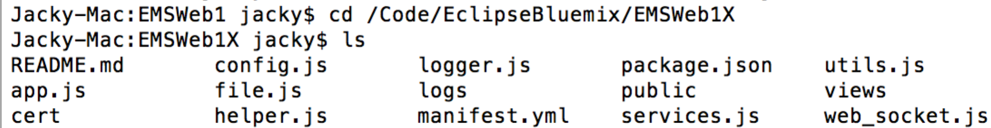

2. Input command line and input “cf login -a <https://api.ng.bluemix.net>”, then input your email and password for your account on Public Bluemix.

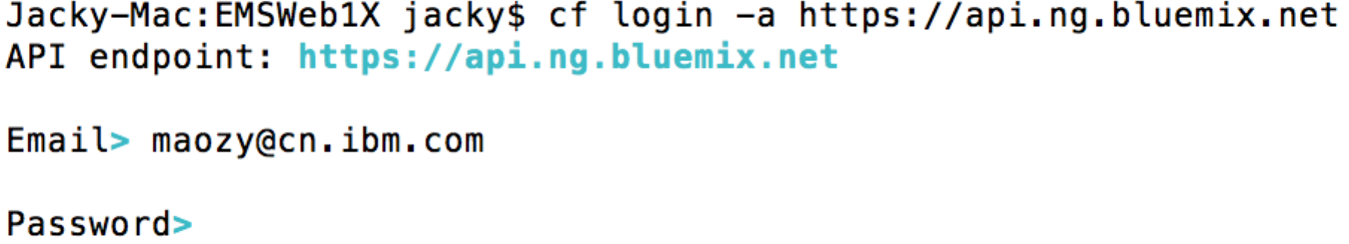

3. Select the target org and space

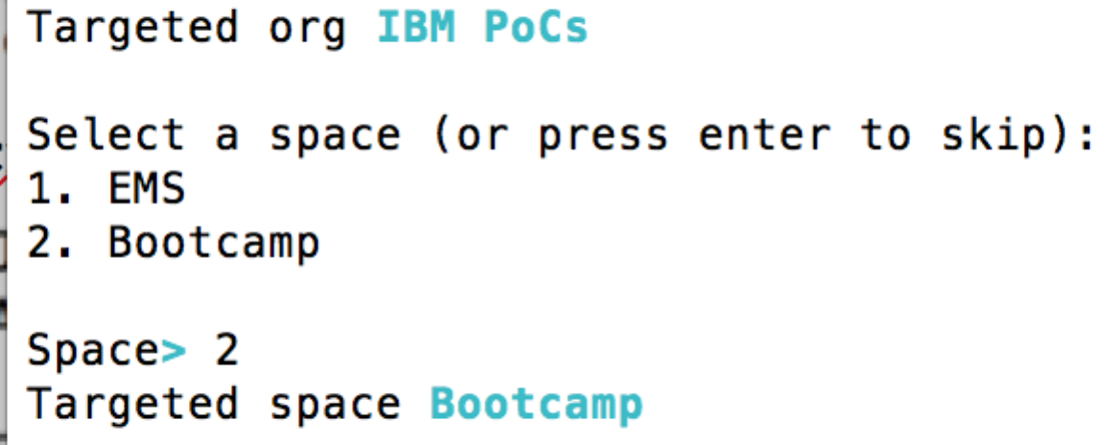

4.Change the host and name for manifest.yml in the root folder

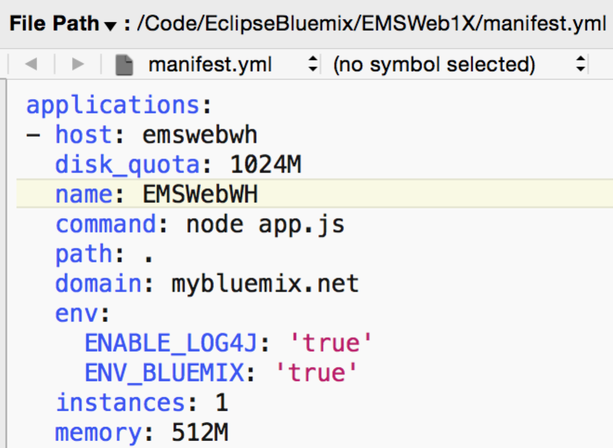

5. Push your app with the command “cf push”.



Then you can see the application running from here:

http://emswebwh.mybluemix.net/